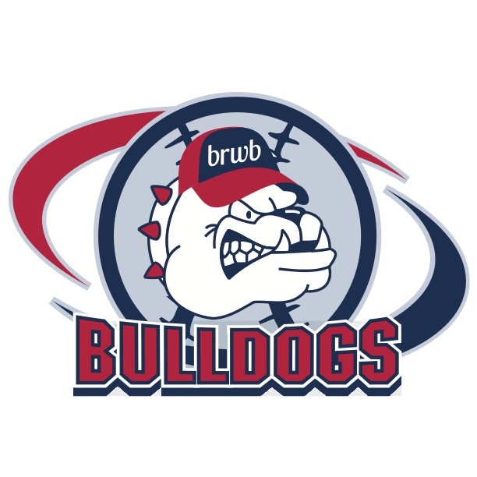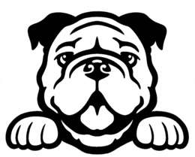

**Burr Ridge – Willowbrook Little League 2025 Participant Waiver**

I understand that in consideration and exchange for, and as a condition of my participation in any and all Burr Ridge – Willowbrook Little League, NFP.(hereinafter BRWBLL ) tournament(s), game(s), showcase(s), practice(s), and/or related activit(y)/(ies) (collectively, “event(s)”), I knowingly and freely release and indemnify BRWBLL and all BRWBLL board members, volunteers, sponsors, advertisers, insurers, facility owners of the premises used, promoters, vendors, service providers, and related independent contractors from all responsibility to me, my estate, heirs, executors, personal representatives, insurers, successors and assigns for anything that occurs during the event(s). It is my intention that this release and indemnification extend to my participation in the event(s) and to my use of any and all event(s)-related facilities and/or connected services, including but not limited to, my use of the facilities and/or services during the event(s) and any practice or warm-up prior to the event(s), as well as my use of the facilities and/or services following the event(s).

I acknowledge that by signing this document, I am assuming risks, and agreeing to indemnify, not to sue, and release from liability, the organizer of event(s), BRWBLL, and all owners, employees, volunteers, sponsors, advertisers, parent organizations, subsidiaries, affiliates, dbas, agents, insurers, facility owners of the premises used, promoters, vendors, service providers, and related independent contractors (collectively, “releasees”), and that I am giving up substantial legal rights. This release is a contract with legal and binding consequences, and it applies to all games, showcases, practices, and/or related activities associated with the event(s), regardless of whether or not specifically listed above. I have read this document carefully before signing, and I understand what it means and what I am agreeing to by signing.

I understand and acknowledge that baseball and/or the event(s) involve inherent risks and dangers of serious bodily injury, including permanent disability, paralysis, and death, as well as being exposed to and/or infected with the recent covid-19 disease (and all its variants), viral infections, bacterial infections and other communicable diseases and illnesses, that may result in sickness, permanent disability, paralysis, and death ("risks"); baseball is an inherently dangerous activity, and I fully realize the dangers of participating in this/these event(s). I also understand that by participating in the event(s) and pre-/post-event activities, I am exposing myself to the possibility of serious injury or even death to my person, as well as damage to my property. These possible injuries, death, and/or damages may result from my own actions or inactions, as well as the actions or inactions of others, the rules of play, and the condition of the facilities and/or equipment. Further, there may be other risks not known to me and not reasonably foreseeable at this time. I have considered the nature and extent of the risks involved, and I knowingly and voluntarily accept these stated risks and fully assume the risks associated with such participation. I additionally consent to treatment in the event of an emergency or other incident in which, in the reasonable judgment of the on-site personnel, I require medical care.

I hereby for myself, my estate, heirs, executors, personal representatives, insurers, successors and assigns, agree with releasees as follows:  
I hereby waive, release, discharge, hold harmless, and promise to indemnify and not to sue the releasees, their officers, agents, officials, employees, successors, and/or assigns from any and every claim or right of action of any kind or nature, including claims arising from the releasees’ own negligence, which arises out of or results from my participation in this/these event(s). I also agree to indemnify and hold harmless the releasees from all such claims or rights of action, including costs, monetary loss or expense in any way related to or arising out of those claims or rights of action, including attorney fees.

It is my intention that this waiver of liability agreement, and the indemnity and hold harmless provision described above, shall cover any claim or demand for injury to or death of any person, or any damage to or destruction of any property, or any claim or demand of any kind or nature whatsoever including but not limited to, injury to or death of any person or damage to or destruction of any property, any damage to my reputation, business, or business relationships which may arise out of any acts or omissions of the releasees, or any of the releasees’ officers, agents, officials, employees, successors, and/or assigns, even if said act or omission would be considered negligent under applicable circumstances.

By signing this waiver of liability agreement, I do not release anyone from any damage I suffer from intentional acts designed to harm either me or my property. However, I do knowingly release the releasees from liability that might be imposed on them by law or equity for such acts of their officers, agents, officials, employees, successors and/or assigns that have not been directed, adopted, or ratified by an officer or director of releasee(s).

I declare that I have read this waiver of liability agreement and fully understand that no officer, agent, official, employee, successor and/or assign of the releasees is authorized to vary any term or provision of this waiver of liability agreement. I expressly agree not to rely on any such variance or representation if any is made. I further represent that the participant listed on the related entry form possesses the standard of competence necessary and is physically fit to compete in this/these event(s). I further represent that the equipment to be provided and utilized by the participant is suitable for participation in this/these event(s).

I certify that I shall comply with all BRWBLL rules, and I specifically agree that BRWBLL’s interpretation of rules, decisions enforcing rules, interpretation of penalties in connection with enforcement of rules, timing of events and decisions as to winners and rankings shall be final and not subject to protest of any kind. No decision of BRWBLL with respect to game, showcase, or personal player metrics results may be challenged by litigation or otherwise. I understand that any statements made by me or anyone acting on my behalf that challenge the integrity of BRWBLL decisions with respect to game, showcase, and/or personal player metrics results will cause irreparable harm to BRWBLL business reputation and subject me to damages under applicable law. I also certify that I have read and will comply with all supplemental or amended rules specifically published for the event(s) in any event bulletins and/or on the BRWBLL website.

This agreement is being made and entered into under the laws of the state of Illinois and shall be governed and interpreted in accordance with the laws of said state. This agreement embodies the entire agreement of the parties (participant and BRWBLL). No modification of this agreement shall be of any effect unless it is made in writing and signed by all the parties to the agreement.

I certify that I have the consent of my parent or guardian as indicated below

I am the parent or legal guardian of ("the participant"). On behalf of the participant, I hereby irrevocably and unconditionally agree to of the terms of the above 'participant release'. I also, for myself and on behalf of my heirs, estate, insurers, successors and assigns, hereby release, indemnify, and hold harmless the releasees (defined above), with respect to any and all claims or causes of action I may have for damages for personal or bodily injury, disability, death, loss or damage to person or property, whether arising from the negligence of any or all of the releasees or otherwise, to the fullest extent permitted by law.

Media Release

As a condition of participation in a BRWBLL, and/or an affiliate sponsored event, I hereby grant to BRWBLL and sponsors the absolute and irrevocable right and unrestricted permission to use my name, signature, likeness, image, voice and/or appearance as such may be embodied in any photos, video recordings, audiotapes, digital images, and registered contact information, taken or made on behalf of BRWBLL or its affiliates, at all events that I participate in relating to BRWBLL with all advertising rights reserved by BRWBLL. I understand that the events may be photographed, videotaped, or otherwise recorded and I agree that BRWBLL may use my name and likeness, in any form without regard to alterations, in photographs, videotapes, audiotapes and other media, without any additional consideration to me or any third party. I acknowledge that I will not receive any compensation for the use of such images. signatures, video, likeness, and all other promotional purposes.

_____________________________________________________

Participant (printed name)

_____________________________________________________ _______________

Parent and/or Legal Guardian (signed name) Date